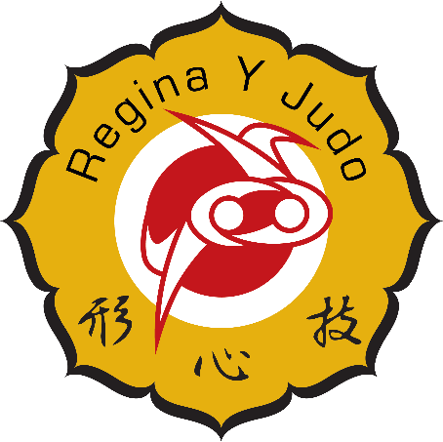
Regina Y Judo Club October News Letter

Upcoming Events
Swim Night – Monday October 16th, 6:30PM Sandra Schmirler Centre
Kinder, Youth I & Youth II Classes are invited to come out and have some off the mat fun!
- Parent or guardian must be present for this event, our coaches are great, but they are not lifeguards!
- Club members fees are covered.
- Parents and siblings must pay their way.

Watrous Judo Tournament – Sunday November 19th, Watrous
Youth I, Youth II & Adult/Teen classes
- Club member fees are covered by the club.
- More information is available under the “Events” tab, on the Regina Y club website.

Saskatchewan Winter Games
Congratulations to Bishop Sommerfeld and Blair Taylor for being selected as the coaches for the Saskatchewan Winter Games for the Regina District. The Saskatchewan Winter Games will take place in North Battleford on February 18 -21, 2018. The Regina Y Judo Club will be holding a practice on October 7 from 9:00to 10:30 for all eligible athletes. There will also be a province wide practice for all eligible athletes in Watrous on October 28. Blair and Bishop are taking a 15 passenger van to Watrous for this event and would love to fill it. There will be a $20 fee to cover the cost of the van. SWG eligible athletes are those born 2003-2006 and hold a minimum rank of Orange belt.
For more information about the SWG please visit http://saskgames.ca/winter/sports/judo

October Skills

Youth 2
Nage waza (Throwing techniques)
Ippon Seoi Nage http://judoinfo.com/ippon-seoinage/

Ne waza Ground techniques)
Chicken Wing turnover https://www.youtube.com/watch?v=okHUQ7gbs4g

Osae Komi Waza (Hold down techniques)
Hon Kesa Gatame Scarf Hold http://judoinfo.com/pinning/

Ukemi Waza (Falling techniques)
Forward roll break falls http://www.judo-ch.jp/english/knowledge/ukemi/

Youth 1
Nage waza (Throwing techniques)
Ippon Seoi Nage One Arm Shoulder https://youtu.be/SGHQrj09O-g
O Soto Gari Major Outer Reaping https://youtu.be/99TfKozouTM
Ne waza (Ground techniques)
Chicken Wing https://youtu.be/Tg5L4UcP2j4
Bump Sweep https://youtu.be/ufzd2G3Kaw8
Osae Komi Waza (Hold down techniques)
Yoko Shiho Gatame Side 4 corner hold https://youtu.be/Y42wALvGKvU
Mune Gatame Chest Hold https://youtu.be/nOv6nW6BqNI
Ukemi Waza (Falling techniques)
Zenpo Kiaten Ukemi Rolling Breakfall https://youtu.be/ztmcgEuzo9Y

Kinder
Nage Wasa (Throwing techniques)
Ippon Seoi Nage One Arm Shoulder Throw Http://youtu.be/Fyoy5DWmxzY
O Goshi Major Hip Throw Http://youtu.be/1ak4qnBd8ME
Osae Komi Waza (Hold down techniques)
Mune Gatame Chest Hold https://youtu.be/nOv6nW6BqNI

