Judo Saskatchewan 2017 Awards Banquet
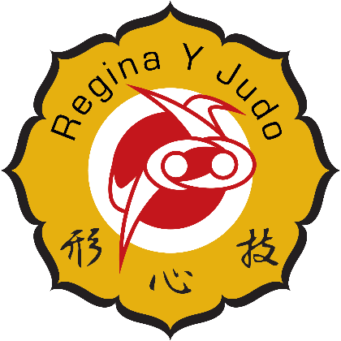

Hosted by The Regina Y Judo Club
Location: Austrian Club
Address: 320 Maxwell Crescent, Regina

Doors open: 7:00pm
Supper begins: 7:30pm

